Anatomical Atlas

**Project Documentation**

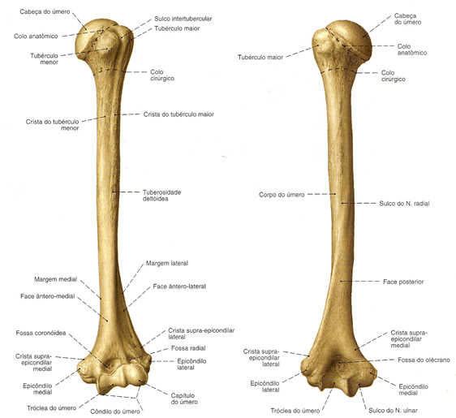

Ráfagan Abreu, Rodolpho Pinto,  
Leonardo Bonfanti, Pedro Roberto

**Brazilian Educational Program for iOS Development**

Revisions

| Version | Primary Author(s) | Description of Version | Date Completed |
| --- | --- | --- | --- |
| 1.0 | Ráfagan | Document creation, structure and join of previous finished content made | 08/04/14 |
| 1.1 | Leonardo | Project Development Plan updated | 12/04/14 |
| 1.2 | Pedro | Critical and Basic questions updated | 12/04/14 |
| 1.3 | Ráfagan | Document Revision | 19/04/14 |
| 1.4 | Ráfagan | Document Executive Summary updated | 20/04/14 |
| 1.5 | Pedro | Critical and Basic questions updated | 27/04/14 |
| 1.6 | Leonardo | Critical Path Diagram added | 03/05/14 |
| 1.7 | Ráfagan e Rodolpho | Regular Questions Updated | 16/05/14 |
| 1.8 | Leonardo | Project Development Plan and Critical Path Diagram updated | 18/05/14 |
| 1.9 | Ráfagan | Research Synthesis and Solution Proposal added. Also, guide questions revised | 18/05/14 |
| 1.10 | Leonardo e Ráfagan | Guide Questions categories revised | 20/05/14 |
| 1.11 | Pedro | Gantt Updated | 20/05/14 |

Contents

1.1 Introduction 1

1.2 Big Idea and Essential Question 1

1.3 Challenge 1

1.4 People Related 1

1.5 External Links 2

2.1 Critical Questions 1

2.2 Regular Question 5

2.3 Basic Questions 8

3.1 Mind Map Diagram 1

3.2 External Activities 5

3.2.1 3D Bones Modeling 5

3.2.2 Database for Media 6

3.2.3 Unity3D Acquest 6

3.2.4 Stereoscopy Usage 6

3.2.5 GUI (Graphical User Interface) 6

3.3 Internal Activities 7

3.3.1 System Documentation 7

System Architecture 7

Domain Model 7

Interaction Diagrams 8

Class Diagram 8

Activity Diagram 9

Statecharts 9

Components Diagram 9

Development Environment 9

External Systems and Components Used 10

3.3.2 System Development 10

Study of Unity 3D/C# 10

Data Model 10

Code Implementation 12

3.3.3 Version Control System 13

Subversion Environment 13

TRUNK 14

BRANCHES 14

TAGS 14

3.3.4 Diagram of Unit Tests 14

Test Classes 14

Classes with Business Rules 14

Test Case 15

Test Suit 15

3.3.5 GUI (Graphical User Interface) 15

Logo 15

Navigation 15

Content Presentation 16

3.3.6 Performance 16

Stability Test 16

Stress Test 16

Load Test 17

3.4 Evaluation 17

3.4.1 Rendering Images 17

3.4.2 Stereoscopy Behavior 17

Device/Projection 17

3.4.3 Ratification with user 18

Presentation 18

Project Documentation 18

4.1 Synthesis of the Research 19

4.2 Rational Solution Proposal 19

5.1 Critical Path Diagram 21

5.2 Gantt 22

5.3 Backlog 22

# Executive Summary

## Introduction

Anatomical Atlas is an application that aims to facilitate the study of human body bone structures using stereoscopy. The App should be able to recognize the anatomical part viewed through the iPad camera, allowing you to add information concerning the structure.

A 3D model database will be created, enabling 3D visualization of anatomical structures. This 3D volumes of the human body will include the bones segmentations and finally a quiz test to measure the user learning.

In a second moment, the goal will be add augmented reality support, also not being “ruled out” the possibility of integration with FTD Digital at PUCPR.

## Big Idea and Essential Question

**Big Idea:** Human Health / Education.

**Essential Question:** How assist students in biology areas to study human anatomy bone efficiently and interactively?

## Challenge

Nowadays, the anatomic study of human body still is done in 2D orthographic projections, difficulting the learning process of one most important society professional: the health doctors. Anothers anatomical modern resources try to improve the learning curve with 3D models, but still without the student interation, which makes harder the perspective notion of the shape.

In this way, our challenge is create an app that helps in the study of human anatomy bone with 3D stereoscopic visualization translated by the iPad camera using pattern matching techniques to automatically recognize the anatomical structure. This app could improve the med students life and others areas interested in body forms too, like illustrators.

## People Related

Project Group:

Leonardo Bonfanti: Computer Engineering graduation student at PUCPR.

Pedro R. Nadolny: Computer Engineering graduation student at PUCPR.

Ráfagan Abreu: Teacher at PUCPR, graduated in Game Development Course. Computer Vision Master Degree in progress. Bitch.

Rodolpho Pinto: Game Development Course graduation student at PUCPR.

Teachers:

Breno Azevedo: Unity Engine Specialist.

Edson Justino: Project Mentor.

Fábio Binder: General BEPiD Project Manager.

Mark Joselli: Anatomical Atlas Team Leader.

Vinícius Godoy: Computer Graphics Specialist.

## External Links

[Google drive](https://drive.google.com/folderview?id=0B7YQg2YS57P5SHliY2N3cVphMnc&usp=sharing).

# Guiding Questions

*\*Its important to make clear that none of the answers below its our final answers and we will get the best answers thought out the process of our project, we even may add more questions during the process. We pretend to update this document as often as possible.*

## Critical Questions

The most important questions related to the project. They define the application core and what we must know.

|  |  |  |  |  |
| --- | --- | --- | --- | --- |
| Question Number | Guiding Questions | Guiding Activities/Resources | Answers (What did we learn) | Evaluation (Assessment Method) |
|  | *List all of the questions that you need to answer to find the best solution to your challenge.* | *List activities and resources you will use to answer each guiding question.* | *After completing the guiding activity what did you learn about each guiding question?* | *How will you assess whether you have effectively answered the question?* |
|  | How to detect bone structures using iPad camera? | Talk with:  - Edson Justino, Atlas RV project mentor.  -Teachers of biological areas.  - Computer graphics professionals  Read in:  [Pattern Matching Wikipedia](http://en.wikipedia.org/wiki/Pattern_matching)  [Object Recognition Article](http://citeseerx.ist.psu.edu/viewdoc/download?doi=10.1.1.42.8513&rep=rep1&type=pdf)  [Pattern Matching Projects Proposal Examples](http://www.comp.nus.edu.sg/~cs4243/project2012/projects.html)  [Image Segmentation Wikipedia](http://en.wikipedia.org/wiki/Image_segmentation) | Using Pattern Recognition Approaches, specifically Template Match and Feature Match | Ráfagan is studiyng pattern matching techniques in his master degree with Edson Justino |
|  | Which features the app gonna provide? | -Discussion between members and mentor of the project.  -Searching App Store for similar apps.  - Guidelines from Apple and Mobile Devices. | Stereoscopy, Quiz for learning evaluation proposes, maybe augmented reality, others to come. | From the meetings of the project we had so far and the project documentation. |
|  | Which computer graphics techniques we will need to draw 3D images? | -Studying 3D graphic engines documentation.  -Computer Graphics books, Like OpenGL SuperBible and iOS core graphics documentation.  -Vinícius Godoy, computer graphics expert. | The team decided to use Unity 3D engine to build the app, because of the project deadline and the large difficult to build a 3D engine and a flexible 3D model reader | Discussions with project resource Vinícius Godoy |
|  | How to make a good UI? | -Talking with Designers and iOS interface experts.  -Looking at App Store for good UI’s.  -Researching at books, documentation, internet, etc.  Watch:  [WWDC 2013 Icon/UI](http://www.youtube.com/watch?v=eRUplOgpgyA) |  |  |
|  | How the app UI gonna be? | -Discussion between project members and Edson Justino.  -Making a Wireframe.  -Search for ideas at App Store. | Will be simple, with easy interaction. The intent is the user starts using the application without tutorials. |  |
|  | How many quiz questions will be needed to evaluate user learining rate? | Talk with…  -Educators.  -Psychologists.  -Biological area teachers. |  |  |
|  | Which information will be displayed about a specific bone? | -Biological area teachers.  -Discussion between project members and Edson Justino.  -Test with users. |  |  |
|  | How information will be displayed about a specific bone? | -Discussion between project members and Edson Justino.  -Test with users.  -Look for similar apps at App Store. |  |  |
|  | How the app will help in the study of bone system? | -Biological area teachers.  -Discussion between project members and Edson Justino.  -Ask users what they think. | What we know so far is that the project is meant to replace anatomic books, making information more accessible, and also more detailed and realistic, by applying computer graphics features, like stereoscopy and augmented reality. Also we’ll add a touch of interactive by letting the user move/rotate the bone with the touchscreen. | From the discussions and meetings we had so far. |
|  | Would be possible to make some networking with professionals of the area? | Talk with:  -Fabio Binder  -Edson Justino  -Vinícius Godoy |  |  |
|  | How would be the meetings with other integrants of the project, like researchers masters and PhD in computer graphics | Discuss with all the participants of the project, mainly Edson Justino. | One day in week was allocated for the team meeting. We anticipate general meetings with teachers around 2-3 times a month. |  |
|  | Which professionals would be nescessary for the project? | Talk with:  -Fabio Binder  -Edson Justino  -Vinícius Godoy  - Breno Azevedo | 3D and UI Artists, Designers, others to come. | From the meetings we had so far. |
|  | How to use stereoscopy in our project? | Talk with Edson Justino and stereoscopy researchers of PPGIA. |  |  |
|  | How to learn stereoscopy? | -Talk with stereoscopy researchers from PPGIA.  -Researches on the internet, books, etc. | First we must study the solution itself. To have a better knowledge in practice, the team can use the laboratory images of PUCPR, where we can perform tests. | Meeting with Edson Justino. |
|  | The need of stereoscopy glasses can be a problem for the users? | -Discuss between project members and Edson Justino.  -Search for apps that use the glass.  -Ask for potential users what they think. |  |  |
|  | Can we use OpenCV (Open Source Computer Vision)? | -Discuss between project members and Edson Justino.  -Test it.  -Look for apps that have already used it. | It’s not official, but we might use it. This will help us with computer vision. Also OpenCV has great processing efficiency. | Ráfagan is studying Computer Vision With Edson Justino. |

## Regular Question

More focused questions. Here is what members should know.

|  |  |  |  |  |
| --- | --- | --- | --- | --- |
| Question Number | Questions | Resources | Answers (What did we learn) | Evaluation (Assessment Method) |
|  | Which 3D asset format will be used in 3D asset production? | -3D artists designed for the project  -Breno Azevedo | Probably fbx or obj. | They are the most supported formats of Unity 3D. |
|  | How to manipulate texture in 3D models? | Talk with Vinícius | We will use the embed shader technology available in Unity. | Studies with Unity and previous experience of some members of the group with the tool. |
|  | How to develop a zoom system that makes possible observe the microscopic structures within the macroscopic ones? | -Tutorials of camera move and animation avaliable at Unity website  -Breno Azevedo |  |  |
|  | Would be possible to develop the project in Unity 3D? | -Fabio Binder | Will be possible to use Unity 3D, but some part of code need to be developed using Xcode. | Fabio Binder confirmed. |
|  | If wasn’t possible to use a 3D engine, how long would take to build our own 3D based graphics engine? | -Vinícius | A long time will be need to create a code base that supports all graphic needs of our project, probably all the time that we can use to finish it. Therefore, we'll use the Unity 3D. | Research with team members and consulting teacher Vinicius. |
|  | How the user registration will work? | Discuss between members and Edson Justino. | We will probably make use of a Webserver, but it’s not official and we didn’t discussed this profoundly yet. | From the discussions we had so far. |
|  | How to save the user quiz score? | Discuss between members and Edson Justino. |  |  |
|  | How to organize and document the code? | Discuss between members and Edson Justino.  -Search for code documentation tools.  Some tools:  <Doxygen>  [VVDocumenter](http://maniacdev.com/2013/07/tool-an-xcode-plugin-that-makes-creating-objective-c-documentation-easier)  [Appledoc](http://gentlebytes.com/appledoc/) | We will discuss this on a future meet, as it will be more pertinent when we start coding, but probably we’ll use a library or a plugging. | Discussion beetween members of the project. |
|  | Will the app need a web service with database? | Performance tests | We’re presuming yes, because we will need it for user registration and user information. | From the meetings we had so far. |
|  | Should/Can we also implement Augmented Reality in our project? | -Discuss between members and Edson Justino  -Analyze if it would be pertinent to implement it and if we’ll have resources for it. | We are discussing it yet, but this will be like an extra feature to be added if we have time at the end of the project. | From the meetings we had. |
|  | Should/Can we implement a class mode? (Like a mode to be used simultaneously by a class and a teacher, but it would be fine to be used between 2 people) | -Discuss between members and Edson Justino.  -Analyze if it would be pertinent to implement it and if we’ll have resources for it. |  |  |
|  | How to connect multiple devices simultaneously to use class mode? | -Discuss between members and Edson Justino.  -Research at books, documents, internet, etc.  Read:  [Multipeer Connectivity Framework](https://developer.apple.com/library/ios/documentation/MultipeerConnectivity/Reference/MultipeerConnectivityFramework/_index.html)  [Core Bluetooth Framework](https://developer.apple.com/library/ios/documentation/CoreBluetooth/Reference/CoreBluetooth_Framework/_index.html) |  |  |
|  | How the class mode would be? | -Discuss between members and Edson Justino. |  |  |
|  | Would be interesting put a tutorial of how create the glasses used to watch in stereoscopic | Talk with Justino and stereoscopy researchers from PPGIA. |  |  |

## Basic Questions

Typical questions. No large research needed.

|  |  |  |  |  |
| --- | --- | --- | --- | --- |
| Question Number | Questions | Resources | Answers (What did we learn) | Evaluation (Assessment Method) |
|  | What’s a stereoscopic image? | -Talk with stereoscopic researchers and Edson Justino.  -Search at books, documents, PhD, internet, etc.  Examples:  [Example](http://kottke.org/photos/stereo/lisa_t.jpg)  -[Color Filtering Stereoscopy](http://www.gimpel3d.com/samples/GardenInPrague_STEREO.jpg) | Stereoscopic images are made from the fusion of 2 or more images from slightly different angles relative to some object, making us having a sensation of depth. | We had an presentation about stereoscopy from a master and researcher of the area. We intend to read some of his write works soon. |
|  | The camera of devices is capable to capture a realistic and detailed image? | -Tests  -Look for other apps that make high use of iOS devices camera. | Yes, it can | We just performed some tests with camera and confirmed that. |
|  | Would be pertinent the use of Kinect to pattern recognition and image processing? | Discuss between project members and Edson Justino. | Not this time | The project will need just the camera to apply pattern recognition |
|  | What difficulty the quiz questions will have? | -Talk with educators, psychologists and teachers from the biological area.  -Test with users |  |  |
|  | Everyone will be able to use the app? | -Discuss between members and Edson Justino.  -Test with real users. | As our project deals with knowledge, it would be good to make it available to everyone, or to as many people as possible. But we do not have a conclusion yet. | From the discussions and meetings we had so far. |
|  | Will the app support multiple languages? | Discuss between members and Edson Justino.  Read:  [Stack Overflow](http://stackoverflow.com/questions/5748600/making-multi-language-ios-app) |
|  | How to make our app adequate for multiple regions around the world? | -Search for this characteristic in apps from App Store.  - Discuss between members and Edson Justino. | Multilanguage app, laws from different country’s, non-offensive regional content, others to come. | From the meetings we had so far. |
|  | Would be possible to port the project for the Full Dome (Digital Arena)? | -Discuss between members and Edson Justino.  -PUCPR Approval. |  |  |
|  | Is there any app with similar function in the market? If yes, how to make our app differentiate from others? | -Search App Store, maybe other platform store.  -Discuss to find something that is missing. | What we know till now is that no app has stereoscopy, which would make our app differentiated. | With the Apple Store research we confirmed |
|  | Is this the most complex BEPiD project? | Discuss between members | Probably yes, we’re not sure. | Not just by the fact that our project have more people involved, its also the project that will use the most from devices, including the ROI Finder med project. It is important to notice if our project can have more support from BEPiD. |
|  | Is it possible for us to have a computer graphics master involved? (Vinícius Godoy) | Talk with:  -Edson Justino  -Fabio Binder | Yes! | Vinícius Godoy confirmed participation. |
|  | Why a quiz to evaluate the learning rate of the user? Is there other way to evaluate it? | -Discuss between members and Edson Justino.  -Search for other evaluation methods. |  |  |
|  | What is anatomy? | -Talk with teachers of the biological area  -Research  [Wikipedia Anatomy (PTBR)](http://pt.wikipedia.org/wiki/Anatomia) | Anatomy is the study of the body plan of animals. The study of human anatomy is important because it help us understand the function of organs and structures of the human body. | Researched at the internet. |
|  | How a stereoscopic image is made? | -Talk with stereoscopy researches.  -Research at books, documents, internet, etc.  Resource:  -PPGIA teacher dissertation about stereoscopic Edson Justino will provide us. | A stereoscopic image is made from the combination of 2 or more images with different perspectives over something. | We had a presentation about stereoscopy in one of our meetings. |
|  | How to implement Augmented Reality? | -Talk with Edson Justino  -Research at books, documents, internet, etc.  Research:  [Wikipedia](http://en.wikipedia.org/wiki/Augmented_reality)  [Only Augmented](http://www.onlyaugmented.com/tools-for-developing-augmented-reality/)  Some tools:  [Metaio](http://www.metaio.com/sdk/)  [ArUco](http://www.uco.es/investiga/grupos/ava/node/26) | We didn’t decided yet, but we will probably use some open library of our taste. | From the meetings we had so far. |
|  | Is there any bone characteristic that we won’t be able to determinate just by filming with the device? | -Edson Justino  -Biological area teachers. |  |  |
|  | After we have a stable alpha version of our app, can we test it with PUCPR biological area students, maybe use it in some class? | -Talk with Edson Justino, Fabio Binder.  -PUCPR approval. | Probably yes! | BEPiD will give support to us. |
|  | How to obtain the necessary medical knowledge? | Talk with Justino | Teacher Justino will be performing weekly meetings with medical experts who will supervise the quality of the project for medical area | Justino weekly meetings. |
|  | What books would be interesting for the project? | -Vinicius |  |  |

# Project Development Plan

## Mind Map Diagram

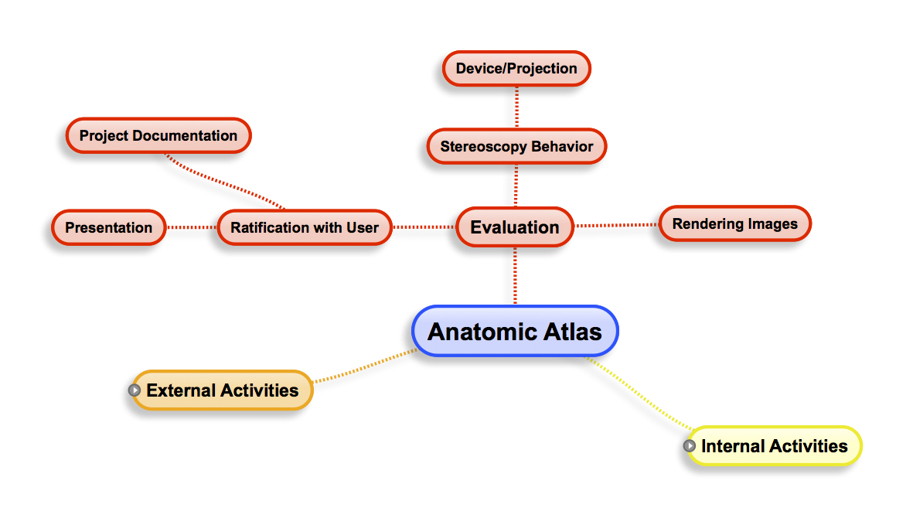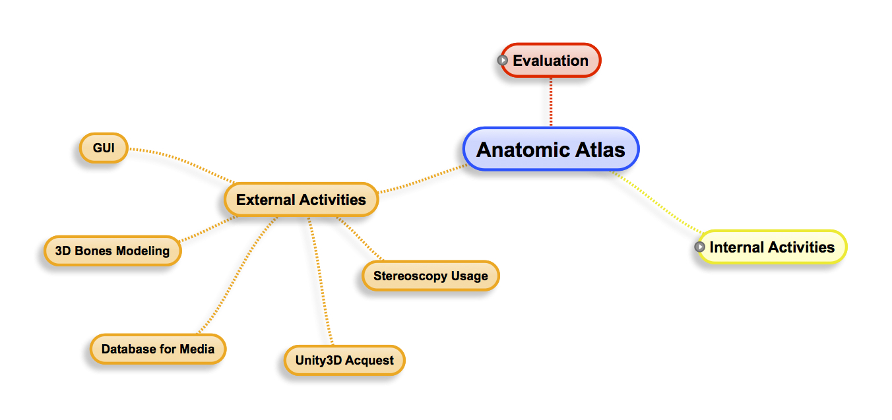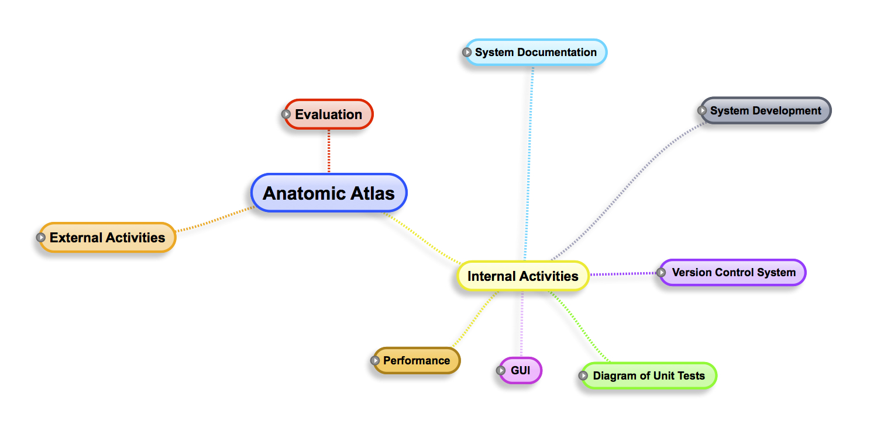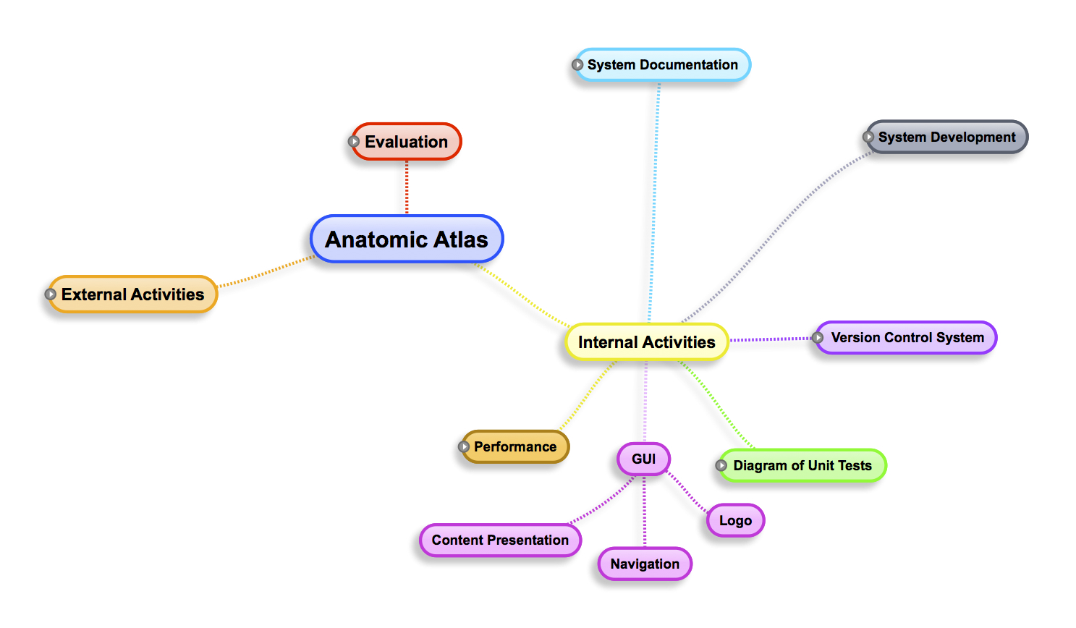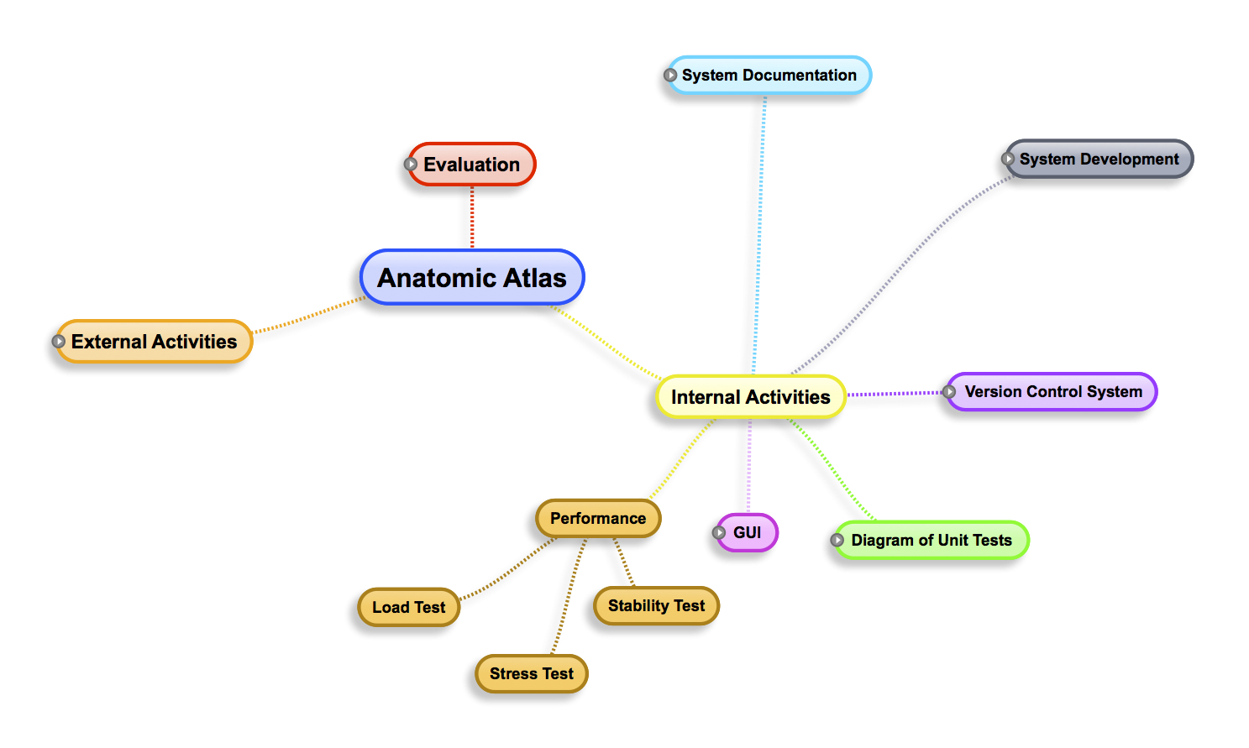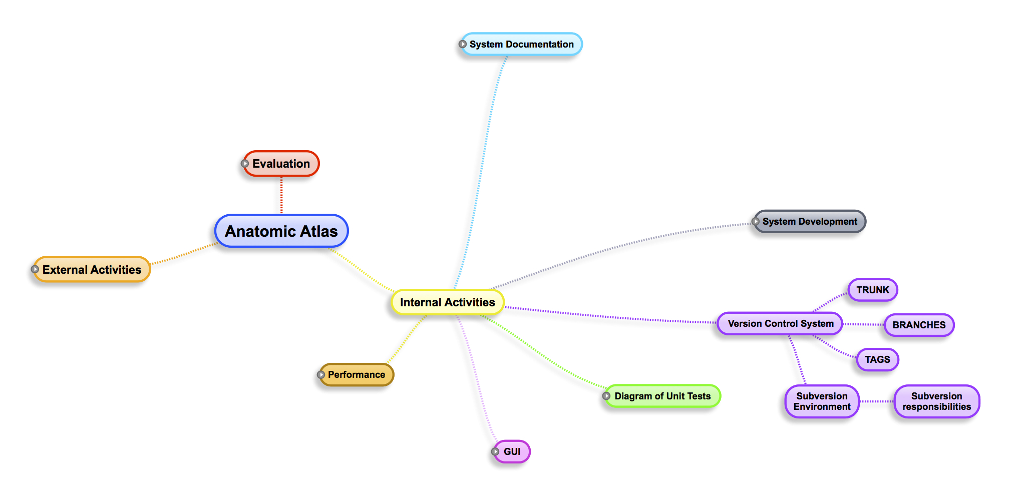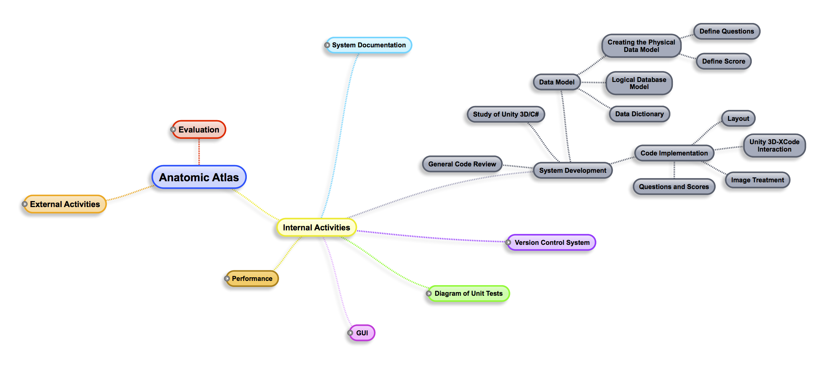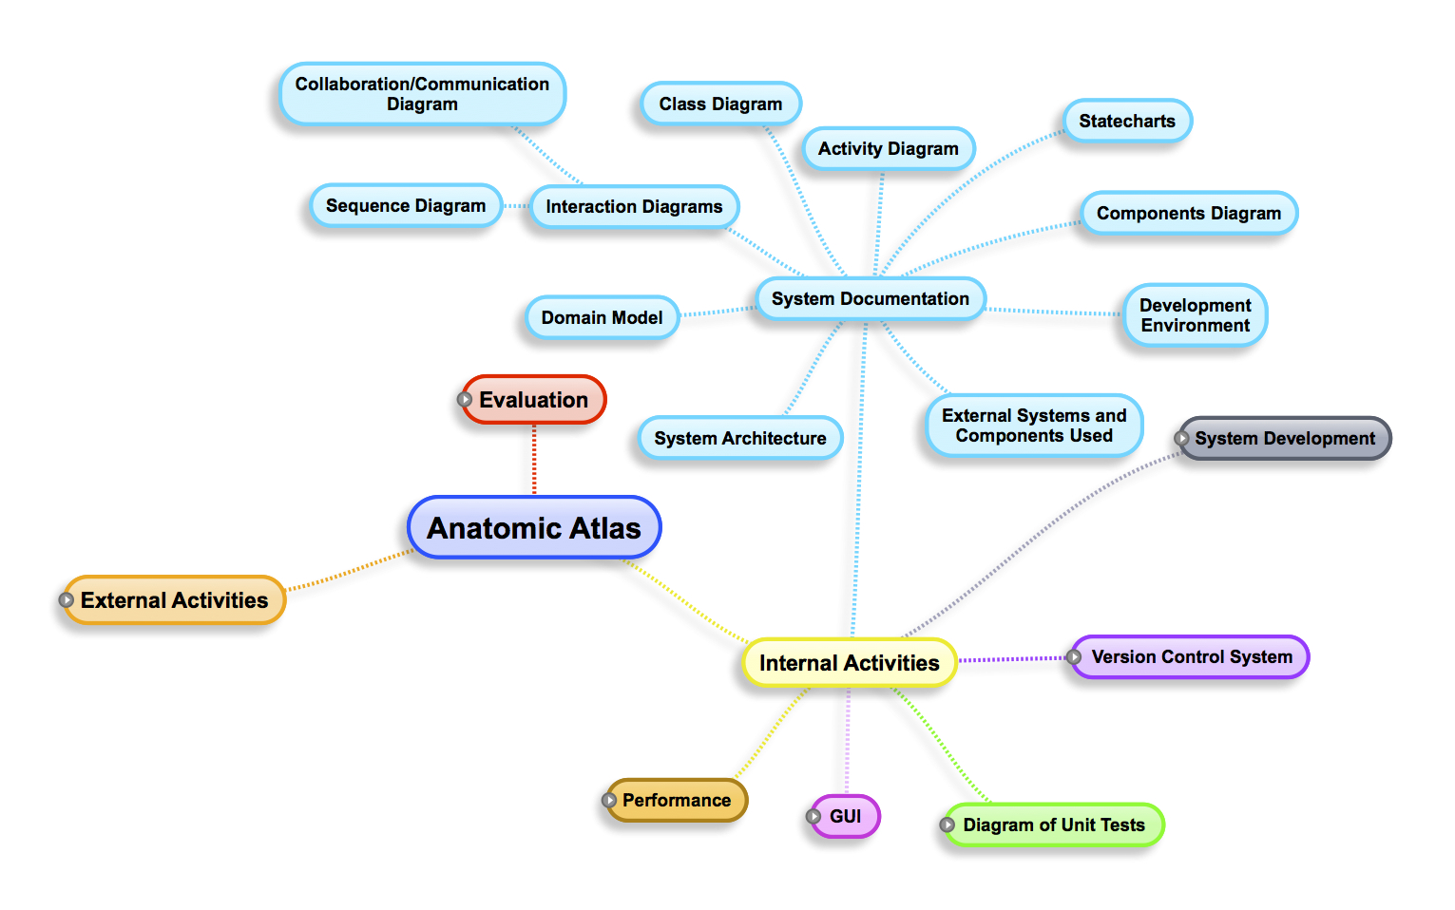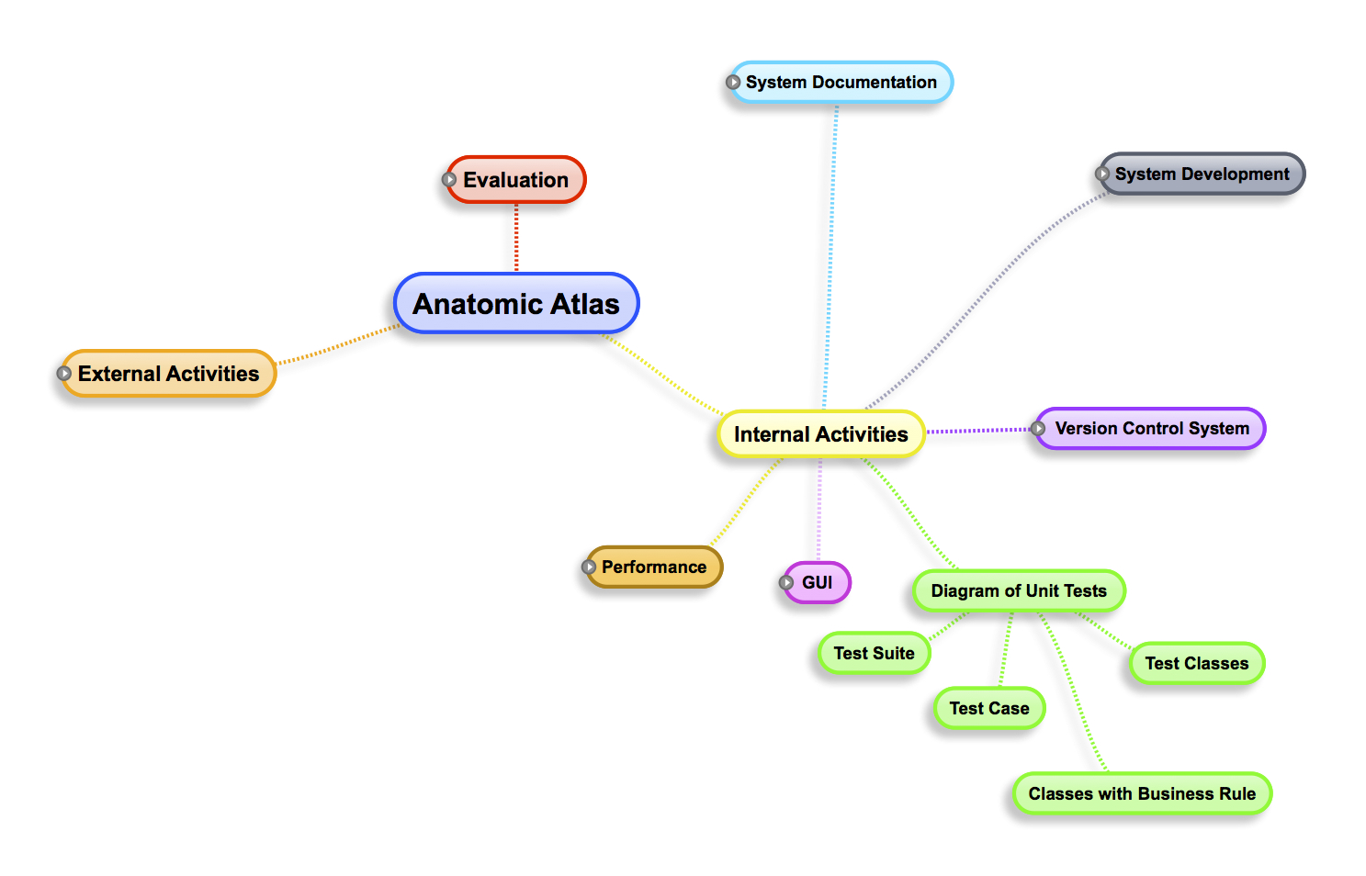

External link for a better view ([click here!](https://drive.google.com/#folders/0B7YQg2YS57P5SHliY2N3cVphMnc))

## External Activities

*Description of External Activities*

### 3D Bones Modeling

**Activity description**: Production of 3D assets to "pre recognition" of bone structures visualized through the camera of device and projected through augmented reality;

**Resources needed**: Professional for modeling of bones;

Medical professionals to define the bony structures to be mapped;

Acquisition of Unity3D for reading models OR teacher advisor for help in programming the models reader;

**Prerequisites:** 3D model's reader;

**Priority:** High;

**Expected results**: Owning pre-made ​​assets for subsequent rendering and projection on the tool used;

**Estimated duration**: 6 months;

### Database for Media

**Activity description**: Server with database processing in the cloud in order to not overload the device with the large amount of assets needed, as well as general registers and records of the users. The short amount of space for permanent storage present on mobile devices is considered as the main problem for performance;

**Resources needed**: Servers;

**Prerequisites:** Prototype;

**Priority:** Normal;

**Expected results**: Server with full application support;

**Estimated duration**: 2 weeks;

### Unity3D Acquest

**Activity description**: Acquisition of a 3D graphics engine for application development;

**Resources needed**: Resources to purchase the pro version;

**Prerequisites:** No;

**Priority:** High;

**Priority**: Environment optimized for rendering;

**Estimated duration**: 2 weeks;

### Stereoscopy Usage

**Activity description**: Linking the project usability with the stereoscopy usage;

**Resources needed**: Resources for tests as projects and 3D glasses;

**Prerequisites:** No;

**Priority:** Normal;

**Expected results**: Have a more real and interactive visualization;

**Estimated duration**: 6 weeks;

### GUI (Graphical User Interface)

**Activity description**: Production of the interface layout;

**Resources needed**: Graphic artist;

**Prerequisites:** StoryBoard (prototype);

**Priority:** Normal;

**Expected results**: Get the application layout;

**Estimated duration**: 2 months;

## Internal Activities

*Description of Internal Activities*

### System Documentation

**Activity description**: Documentation of the system code. Will be branched in proper subsequent activities;

**Prerequisites:** No;

**Priority:** Low;

**Estimated duration**: 3 weeks;

#### System Architecture

**Activity description**: Study about architecture and infrastructure of the system, as well as network settings and used softwares, and the minimum scale of connections;

**Resources needed**: Project participants;

**Prerequisites:** No;

**Priority:** High;

**Expected results**: No impediment in the software, hardware or network connections;

**Estimated duration**: 3 days;

#### Domain Model

**Activity description**: Production of the first conceptual model of the class diagram. Later, this diagram should be validated and complemented to compose the final class diagram;

**Resources needed**: Project participants;

**Prerequisites:** No;

**Priority:** Normal;

**Expected results**: First concept of the Class ciagram completed;

**Estimated duration**: 3 days;

#### Interaction Diagrams

**Activity description**: Composed of sequence diagrams and collaboration. It models the dynamic aspects of the system showing the interaction formed by a set of objects allowing to identify messages that may be sent between them;

**Resources needed**: Project participants;

**Prerequisites:** No;

**Priority:** Low;

**Estimated duration:** 2 days;

##### Sequence Diagram

**Activity description**: Presenting sequence diagrams essential to the system;

**Resources needed**: Project participants;

**Prerequisites:** No;

**Priority:** Low;

**Expected results**: Represent object interactions arranged in a time sequence;

**Estimated duration**: 1 days;

##### Collaboration/Communication Diagram

**Activity description**: Present collaboration/communication diagrams essential to the system;

**Resources needed**: Project participants;

**Prerequisites:** No;

**Priority:** Low;

**Expected results**: To get a description of pattern of interaction between objects;

**Estimated duration**: 1 days;

#### Class Diagram

**Activity description**: To deliver the class diagram completed and validated;

**Resources needed**: Project participants;

**Prerequisites:** No;

**Priority:** Normal;

**Expected results**: Class Diagram;

**Estimated duration**: 3 days;

#### Activity Diagram

**Activity description**: Present the activity diagram to represent the section of tasks and flow from one activity to another in the system;

**Resources needed**: Project participants;

**Prerequisites:** No;

**Priority:** Low;

**Expected results**: Detailing of the workflow methods;

**Estimated duration**: 2 days;

#### Statecharts

**Activity description**: Specify the sequence of states through which the object can pass during its lifetime in response to events;

**Resources needed**: Project participants;

**Prerequisites:** No;

**Priority:** Low;

**Expected results**: Mapping the sequence of object states;

**Estimated duration**: 3 days;

#### Components Diagram

**Activity description**: Introduce the organization and dependencies between components;

**Resources needed**: Project participants;

**Prerequisites:** No;

**Priority:** Low;

**Estimated duration**: 3 days;

#### Development Environment

**Activity description**: Present the development softwares, hardware equipment and networks that are essential for the development of the system;

**Resources needed**: Project participants;

**Prerequisites:** No;

**Priority:** Low;

**Expected results**: Better organization of the solution as a whole;

**Estimated duration**: 1 day;

#### External Systems and Components Used

**Activity description**: Describe the external systems and components that will be used in the system;

**Resources needed**: Project participants;

**Prerequisites:** No;

**Priority:** Low;

**Expected results**: Facilitate or complement the development of the system;

**Estimated duration**: 1 day;

### System Development

**Activity description**: Implementation of the system;

**Resources needed**: Project participants;

**Prerequisites:** Unity3D study;

**Priority:** High;

**Estimated duration**: 6 months and 3 weeks;

#### Study of Unity 3D/C#

**Activity description**: Continuously study solutions that Unity3D provide;

**Resources needed**: Project participants;

**Prerequisites:** No;

**Priority:** High;

**Expected results**: Get good knowledge about the platform Unity3D;

**Estimated duration**: 2 weeks;

#### Data Model

##### Creating the Physical Data Model

**Activity description**: Perform the physical creation of the database, in other words, scripts;

**Resources needed**: Project participants;

**Prerequisites:** No;

**Priority:** High;

**Expected results**: Database structure ready for use;

**Estimated duration**: 1 week;

###### Define Questions

**Activity description**: Define the questions to be presented to the user at the end of their study;

**Resources needed**: Project participants;

**Prerequisites:** No;

**Priority:** Normal;

**Expected results**: Defined questions of the quiz;

**Estimated duration**: 3 days;

###### Define Scores

**Activity description**: Define the score of each question;

**Resources needed**: Project participants;

**Prerequisites:** Defined questions;

**Priority:** Normal;

**Expected results**: Defined questions scores;

**Estimated duration**: 2 days;

##### Logical Database Model

**Activity description**: Present the logical model of the database, which can be the entity-relationship model or object database;

**Resources needed**: Project participants;

**Prerequisites:** No;

**Priority:** Normal;

**Expected results**: Control and documentation;

**Estimated duration**: 2 days;

##### Data Dictionary

**Activity description**: Create the data dictionary of the database;

**Resources needed**: Project participants;

**Prerequisites:** No;

**Priority:** Normal;

**Expected results**: Have documented all the tables, attributes, stored procedures;

**Estimated duration**: 1 day;

#### Code Implementation

**Activity description**: Perform system development;

**Resources needed**: Project participants;

**Prerequisites:** Unity3D study;

**Priority:** High;

**Estimated duration**: 3 months;

##### Layout

**Activity description**: Implement the layout already defined;

**Resources needed**: Project participants;

**Prerequisites:** Interface defined;

**Priority:** High;

**Expected results**: Simple layout with a strong presentation;

**Estimated duration**: 3 weeks;

##### Unity3D-XCode Interaction

**Activity description**: Realize the communication between Unity3D and XCode;

**Resources needed**: Project participants;

**Prerequisites:** Unity3D study;

**Priority:** High;

**Expected results**: Established transfer between platforms without errors;

**Estimated duration**: 2 weeks;

##### Image Treatment

**Activity description**: Set image treatments, such as position, rotation, visualization etc;

**Resources needed**: Project participants;

**Prerequisites:** 3D bones modeling;

**Priority:** High;

**Expected results**: Clean image, with easy interaction and rapid visualization;

**Estimated duration**: 1 month;

##### Questions and Scores

**Activity description**: Implement the questions and scores;

**Resources needed**: Project participants;

**Prerequisites:** Questions and scores defined;

**Priority:** Normal;

**Expected results**: Quiz completed;

**Estimated duration**: 2 weeks;

### Version Control System

**Activity description**: Improve the management of implementations trough versioning the code;

**Resources needed**: Project participants;

**Prerequisites:** No;

**Priority:** High;

**Expected results**: Codes with minimum chances of errors, together with a historical of development;

**Estimated duration**: 1 week;

#### Subversion Environment

**Activity description**: Define what software will be used to work with code versioning;

**Resources needed**: Project participants;

**Prerequisites:** No;

**Priority:** High;

**Expected results**: Better organization of activities and codes;

**Estimated duration**: 1 week;

##### Subversion Responsibilities

**Activity description**: Define the responsibilities of each team member on the versioning;

**Resources needed**: Project participants;

**Prerequisites:** Versioning software defined;

**Priority:** Normal;

**Expected results**: Better organization of activities and codes;

**Estimated duration**: 1 day;

#### TRUNK

It is the folder that contains the files of the latest version (with all amendments) of the module.

#### BRANCHES

The branches are basically a copy of the latest SVN version (usually the latest version of trunk) that are available for developers to conduct the necessary changes, to meet the requests for corrections or developments (SDs).

#### TAGS

Tags act as controllers of versioning made, ​​are the frozen versions of the sources tasks that were performed.

### Diagram of Unit Tests

**Activity description**: Focus on verifying the smallest unit of software design, performing the logical drive test using a sufficient test data to test only the logic of the unit in question;

**Resources needed**: Project participants;

**Prerequisites:** System development should be initiated;

**Priority:** Normal;

**Expected results**: Prevent "BUG'S", tests of success and failure, more confidence in the code;

**Estimated duration**: 2 weeks;

#### Test Classes

**Activity description**: Design and write test classes;

**Resources needed**: Project participants;

**Estimated duration**: 4 days;

#### Classes with Business Rules

**Activity description**: Design and write test classes with business rules;

**Resources needed**: Project participants;

**Estimated duration**: 4 days;

#### Test Case

**Activity description**: Design, write and run for each class;

**Resources needed**: Project participants/Developer;

**Estimated duration**: 2 day;

#### Test Suit

**Activity description**: Design, write and run several test cases;

**Resources needed**: Project participants/Developer and Coordinator;

**Estimated duration**: 2 day;

### GUI (Graphical User Interface)

**Activity description**: Implementation of the interface layout;

**Resources needed**: Project participants;

**Prerequisites:** StoryBoard (prototype);

**Priority:** High;

**Expected results**: Implement the application layout;

**Estimated duration**: 1 month;

#### Logo

**Activity description**: Create the application logo;

**Resources needed**: Project participants;

**Expected results**: Logo created and within of the standards IOS 7;

**Estimated duration**: 1 day;

#### Navigation

**Activity description**: Create the behavior of the navigation in the application;

**Resources needed**: Project participants;

**Expected results**: Navigation created and within of the standards IOS 7;

**Estimated duration**: 1 week;

#### Content Presentation

**Activity description**: Implement the content presentation in the application;

**Resources needed**: Project participants;

**Expected results**: Content presentation created and within of the standards IOS 7;

**Estimated duration**: 3 weeks;

### Performance

**Activity description**: Perform general performance tests in order to ensure the best utilization of the system and the user;

**Resources needed**: Project participants;

**Prerequisites:** Implementation and testing phases must be completed;

**Priority:** Normal;

**Expected results**: Fast communication and great user interaction;

**Estimated duration**: 2 weeks;

#### Stability Test

**Activity description**: Perform tests to verify that the system performance degrades with time;

**Resources needed**: Project participants;

**Priority:** Low;

**Expected results**: System without loss of performance;

**Estimated duration**: 1 week;

#### Stress Test

**Activity description**: Perform tests to determine the maximum capacity of the system;

**Resources needed**: Project participants;

**Priority:** Normal;

**Expected results**: Capacity within the desired patterns;

**Estimated duration**: 1 week;

#### Load Test

**Activity description**: Test performed to check if the system supports a particular desired load;

**Resources needed**: Project participants;

**Priority:** Normal;

**Expected results**: Capacity within the desired patterns;

**Estimated duration**: 1 day;

## Evaluation

*Description of Evaluation Activities*

### Rendering Images

**Activity description**: Conduct performance tests for rendering images to evaluate whether they are being processed in a way that does not disrupt the user experience of our App. What must be assessed is whether the images are being rendered in a timely manner and the image quality, without forcing the device related to its processing power;

**Resources needed**: Project participants;

**Prerequisites:** Some pre-alpha version of the app to be able to perform the test;

**Priority:** High;

**Expected results**: Fast and quality renderings;

**Estimated duration**: 1 week;

### Stereoscopy Behavior

**Activity description**: Check the result of the stereoscopic use.

**Resources needed**: User;

**Prerequisites:** Equipment to support stereoscopic vision.

**Priority:** Low;

**Expected results**: 3D model with high quality and interactive.

**Estimated duration**: 1 month;

#### Device/Projection

**Activity description**: Check the device-stereoscopy interaction;

**Resources needed**: User;

**Prerequisites:** Equipment to support stereoscopic vision and mobile devices;

**Priority:** Low;

**Expected results**: Dynamic parameterization of stereoscopic vision;

**Estimated duration**: 1 month;

### Ratification with user

**Activity description**: Perform ST/SIT and UAT testing for the system to be approved;

**Resources needed**: Project participants (for ST / SIT tests) and final user (for UAT testing);

**Prerequisites:** Prototype ready, implemented and integrated features. Elaborate test cases;

**Priority:** Low;

**Expected results**: Tests performed successfully. Systems working as expected;

**Estimated duration**: 3 weeks;

#### Presentation

**Activity description**: Presentation of the final product;

**Resources needed**: Multimedia features;

**Prerequisites:** Prototype ready, implemented and integrated features. Elaborate test cases;

**Priority:** Low;

**Expected results**: Approval of examining board;

**Estimated duration**: 1 week;

#### Project Documentation

**Activity description**: Delivery of project documentation;

**Resources needed**: No;

**Prerequisites:** Prototype ready, implemented and integrated features. Elaborate test cases;

**Priority:** Low;

**Estimated duration**: 2 weeks;

# Research

## Synthesis of the Research

The main impact of the research on the project was the complexity research conclusion involved in building the 3D engine for iPhone, which is a key issue for the success of the project.

Through research, we found that a good way to make possible the app would be integrating the development environment for iOS with Unity. Teacher Breno Azevedo, Unity expert, is helping us in this task.

Considering the Unity as a company focused on the development of 3D games engine, we will get facilities in the construction of Quiz Test game, maintaining high expectations of the group with the game special effects for the application with the use of Unity shaders. The use of the engine will also make easy the 3D assets integration.

The meeting with the human project resources also enabled us to understand the needs of hiring a 3D artist for the project instead of performing the dynamic creation of bone anatomical parts with the processing of Tomography Images. Besides the complexity involved, would probably need a pre-processing of such images, since the iPad processing power is more limited than on a conventional computer.

The recognition of bone anatomical parts through the camera using pattern recognition, as well as its visualization using augmented reality, would considered possible with the study of one group members directly with Edson Justino, the project mentor, at “Programa de Pós Graduação em Informática Aplicada” (PPGIA) from PUCPR, using a Computer Vision Open Source tool called OpenCV, which is optimized and passible of integration with iOS library.

However, we will keep this project part in a second step, since one PPGIA student noticed at Stanford University the inclination of using stereoscopy for medical applications. We are getting motivated by the results to be obtained by using stereoscopy for displaying anatomical parts on the iPad, since this would represent an innovation to market and target audience of the app that we are proposing.

Also, through research, became clear that we need good UI designers and 3D modelers to the bones, since much of the effort will involve such assets. Regarding the UI, our project will require a great effort on intuitibility, mainly because we’re proposing an educational app.

With respect to the Quiz, we realized that would be ideal if them were stored on an external Web Service and persisted on demand localy with sqlite for better performance on the device. Thus, students can download the type of Quiz they want in a cloud repository.

## Rational Solution Proposal

The Anatomical Atlas is an educational app for iPad, targeted mainly for the medical field, which aims to enable the study of anatomical bone parts of the human body. To fulfill this goal, an interface for 3D bones manipulation, which are displayed on stereoscopic vision, will be developed.

At the end of the study, the student must answer a Quiz Test under the supervision of his teacher, being the Quiz questions stored in a Web Based Database Service. We believe that the quizes stored in the cloud may follow Open Source or Paid licenses as the manufacturer teacher of the issues desires, making the Anatomical Atlas based learning collaborative and globalized.

In a second step, we plan to conduct tests with augmented reality and pattern recognition of anatomical parts, or in Full Total Dome Digital Arena at PUCPR, but this will depend of progress at the first project stage.

O Atlas Anatômico ósseo proposto neste documento representa apenas uma parte do projeto Atlas Anatômico final idealizado, o qual buscará possibilitar o estudo de todo o Sistema Anatômico Humano. Esperamos obter o máximo feedback dos profissionais envolvidos no projeto com o objetivo de agregarmos aprendizado para a versão continuada da aplicação.

The Anatomical Atlas bone proposed in this document represents only a portion of the idealized final Anatomical Atlas project, which will seek to enable the study of all Human Anatomic System. We hope to get as much feedback as possible from professionals involved in the project with the goal of aggregating learning for the next application version.

# Software Development Plan

## Critical Path Diagram

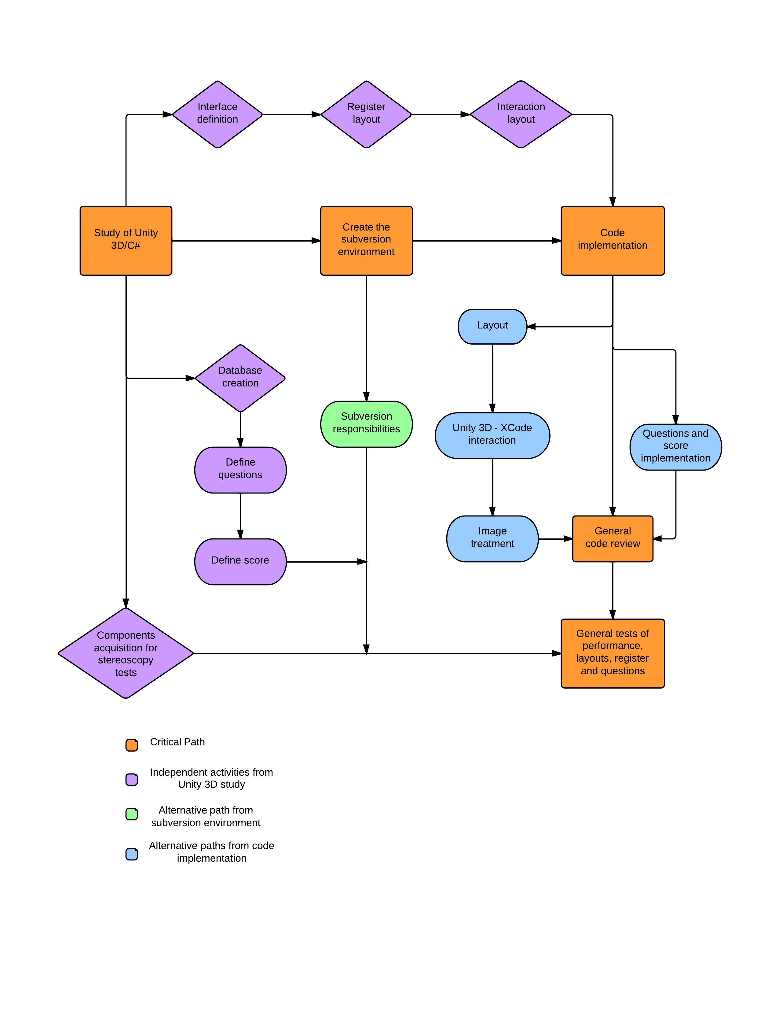

External link for a better view ([click here!](https://drive.google.com/#folders/0B7YQg2YS57P5SHliY2N3cVphMnc)).

## Gantt

[Open here!](http://www.gantter.com)

[Download Here!](https://drive.google.com/file/d/0BztLwRUD2WTDMzZXbDdfaENXQ1E/edit?usp=sharing)

## Backlog

<https://trello.com>

## Wireframe